# Spot and 1M example

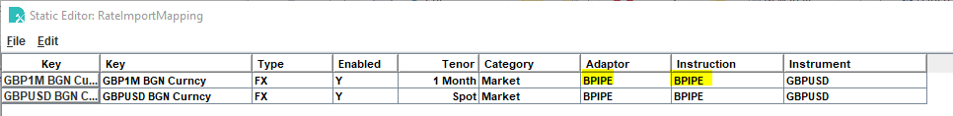

## Key

Bloomberg Topic. The above examples are inclusive of source (BGN in this case) which is how Leumi will configure. Without source would be:

GBP1m Curncy

When defined as above, with multiple sources then Bloomberg select the source. They say do not do this for Leumi. See accompanying Leumi spreadsheet for their currencies and none-source specific topics.

It is possible to override the fields requested. Currently these are defaulted in the twist properties file, but you can do:

GBP1M BGN Curncy?fields=BID,ASK,etc

If this is done, then the mappings may need to be updated under Instruction (see below). At this point there should be no need to do this.

## Adaptor

External System from twist_BIPERateImporter.properties

## Instruction

Defines mappings for extracting BID, ASK etc. In code base here:

data\config\com\eurobase\siena\twist\implementation\siena\rateimporter\instruction.properties

data\config\rateimporter\instruction\bpipe\BPIPE.xml